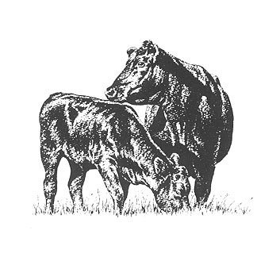
Nebraska Angus Auxiliary
The purpose of this Auxiliary shall be to have persons interested in the welfare of the Angus breed meet together for educational, promotional, social and other functions of this organization. This Auxiliary will follow the guidelines of the American Angus Auxiliary in the promotion and support of the Nebraska Junior Angus Association. It shall be a non-profit organization.
Dues:
Please check the type of membership you desire.
State Membership:
_______ NE Angus Auxiliary Annual Membership $10.00 per year
_______ NE Angus Auxiliary Lifetime Membership $100.00 for lifetime

National Membership**:
American Angus Auxiliary Annual Membership $10 per year
American Angus Auxiliary Lifetime Membership $100

**Please visit www.angusauxiliary.com for the membership application
Activities:
Please check the standing committees of your interest
_______ Awards & Scholarship
_______ Ways & Means- Fundraising Committee
_______ Public Relations/Promotion- Education and Newsletter
_______ Queen Committee

Today’s date________________
Name:
Farm or Ranch Name:
Address:
City: State: Zip Code:
Phone: Email:

Please return this form to NE Auxiliary Secretary:
Kellie Hollman
26230 SW 72nd ST, Hallam, NE 68368

